**Lab 7**

**Name :-** Aryan Dilipbhai Langhanoja

**Date :-** 01-08-2023

**Enrollment No :-** 92200133030

**CO1: To write, test, and debug simple Python programs**

**CO2: To implement Python programs with conditional, loops and functions**

**Task 1:- Abstract Character From String Using For Loop**

**Python Code:**

A = "Aryan Langhanoja"

for var in A :

print(var,end="")

print("")

for i in range(0,len(A)) :

print(A[i],end="")

**Output:**

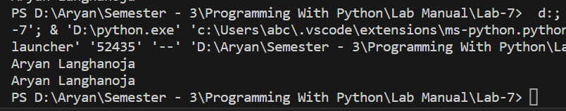

**Task 2:- Print Character Using end**

**Python Code:**

A = "Aryan Langhanoja"

for i in range(0,len(A)) :

print(A[i],end = " * ")

print("\n")

**Output:**

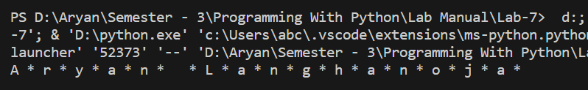

**Task 3:- Using Loops In A List**

**Python Code:**

list1 = ["A","R","Y","A","N"]

for i in list1 :

print(i)

print("\n")

**Output:**



**Task 4:- Find The Average of numbers in a List**

**Python Code:**

list2 = [1,6,7,8,34,56,78,4346,3432987]

for i in range(0,len(list2)) :

sum = 0

sum = sum + list2[i]

print(f"Avergae of {list2} is {sum/len(list2)}")

**Output:**

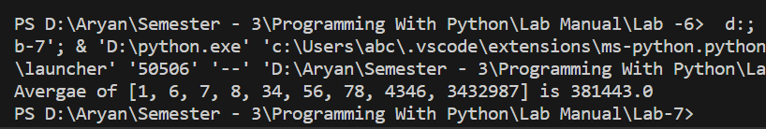

**Task 5:- Use Loop In Tuple**

**Python Code:**

tuple1 = (1,2,345464,74543566,255456,89435)

for i in range(0,len(tuple1)) :

sum = 0

sum = sum + tuple1[i]

print(f"Avergae of {tuple1} is {sum/len(tuple1)}")

**Output:**

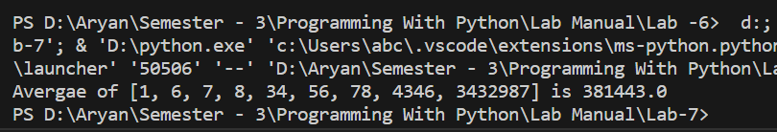

**Output:**

**Task 6:- Use range in for loop**

**Python Code:**

for i in range(0,11) :

print(i)

**Output**

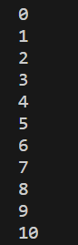

**Task 7:- Find The Factorial**

**Python Code:**

num = int(input("Enter A Number:-"))

ans = 1

for i in range(1,num + 1) :

ans = ans * i

print(f"The Factorial of {num} Is {ans}")

**Output:**

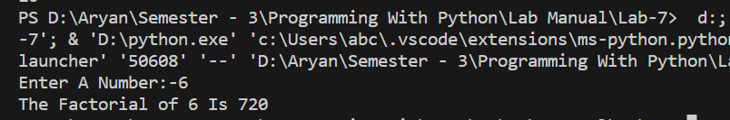

**Task 8:- List Using Range**

**Python Code:**

list1 = ["A","R","Y","A","N"]

for i in range(0,len(list1)) :

print(list1[i])

**Output:**

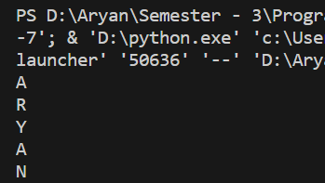

**Task 9:- Member Operator**

**Python Code:**

list3 = ["Meta","Apple","Amazon","Netflix","Google"]

for i in range(0,len(list3)) :

print(f"The Letters of {list3[i]} Is :-")

for j in range(0,len(list3[i])) :

print(list3[i][j])

**Output:**

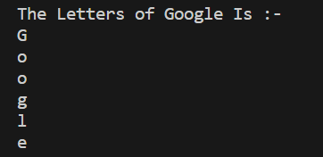

**Task 10:- For loop using else**

**Python Code:**

for i in range(0,10,1) :

if(i > 0) :

print(i)

else :

print("Loop Is Terminated")

**Output:**

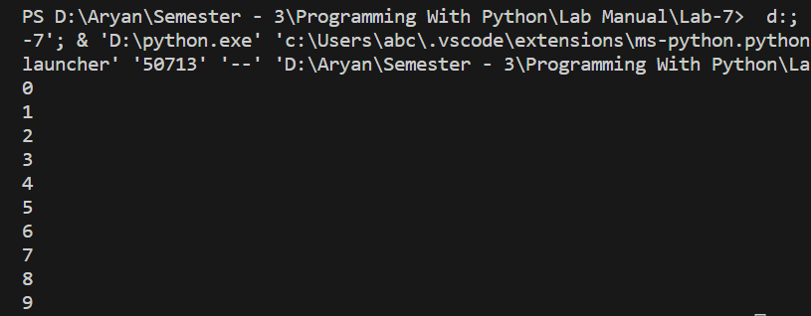

**Task 11:- Nested Loops**

**Python Code:**

list3 = ["Meta","Apple","Amazon","Netflix","Google"]

for i in range(0,len(list3)) :

print(f"The Letters of {list3[i]} Is :-")

for j in range(0,len(list3[i])) :

print(list3[i][j])

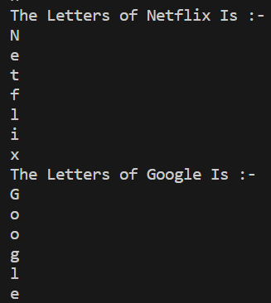**Output:**

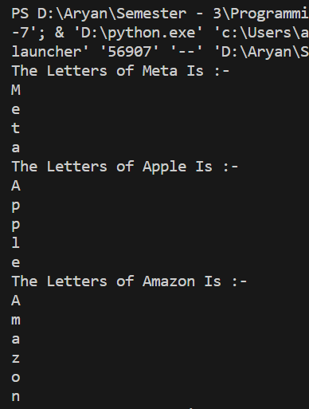

**Task 12:- for loop using break**

**Python Code:**

for i in range(0,10,1) :

if(i > 5) :

print(i)

break

**Output:**

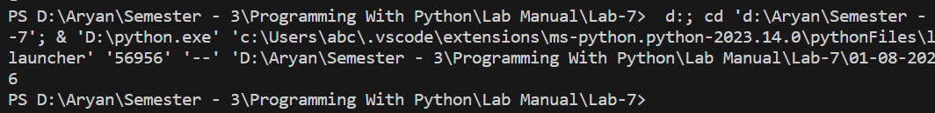

**Task 13:- for loop using continue**

**Python Code:**

for i in range(0,10,1) :

if(i > 5) :

continue

else :

print(i)

**Output:**

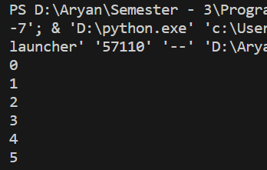

**Post Lab**

**Task 1:-** Write a program in Python to display the Factorial of a number.

**Python Code:**

num = int(input("Enter A Number:-"))

ans = 1

for i in range(1,num + 1) :

ans = ans * i

print(f"The Factorial of {num} Is {ans}")

**Output:**

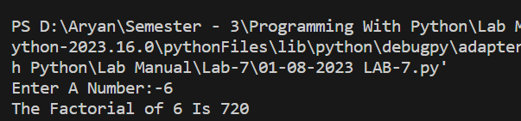

**Task 2:-** Write a program that appends the square of each number to a new list.

**Python Code:**

list4 = [2,4,6,8]

square = []

for i in list4 :

square.append(i**2)

print(square)

**Output:**

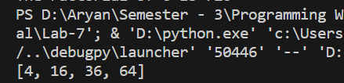

**Task 3:-** WAP to separate positive and negative number from a list.

**Python Code:**

list5 = [9,-5,4,-83,45,78,-45,-345,342345,-54,-224552]

pos = []

neg = []

for i in list5 :

if i >= 0 :

pos.append(i)

else :

neg.append(i)

print(pos)

print(neg)

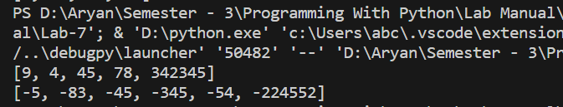**Output:**

**Task 4:-** Write a program to filter even and odd number from a list.

**Python Code:**

list6 = range(1,101)

even = []

odd = []

for i in list6 :

if i % 2 == 0 :

even.append(i)

else :

odd.append(i)

print(even)

print(odd)

**Output:**

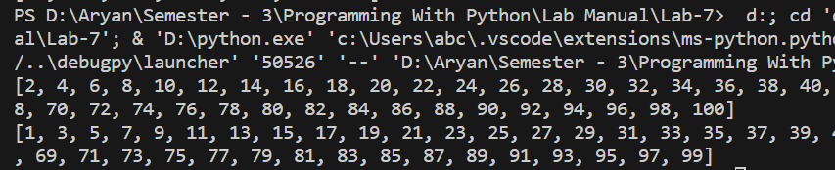

**Task 5:-** Python program to print all the even numbers within the given range.

**Python Code:**

range = int(input("Enter The Ending Number Of Range:-"))

list7 = range(0,range+1)

evenlist = []

for i in list7 :

if i % 2 == 0 :

evenlist.append(i)

print(evenlist)

**Output:**

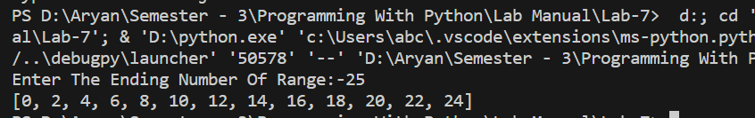

**Task 6:-** Python program to calculate the sum of all numbers from 1 to a given number.

**Python Code:**

addrange = int(input("Enter The Ending Number Of Range:-"))

sum = 0

for i in range(1,addrange+1) :

sum = sum + i

print(f"The Addition Of All Numbers of {range(0,addrange+1)} Is {sum}")

**Output:**

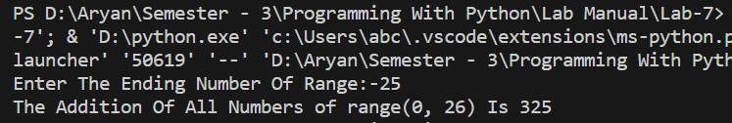

**Task 7:-** Python program to calculate the sum of all the odd numbers within the given range.

**Python Code:**

oddrange = int(input("Enter The Ending Number Of Range:-"))

list7 = range(0,oddrange+1)

oddlist = []

oddsum = 0

for i in list7 :

if i % 2 != 0 :

oddlist.append(i)

oddsum = oddsum + i

print(f"The Addition Of All Numbers of {oddlist} Is {oddsum}")

**Output:**

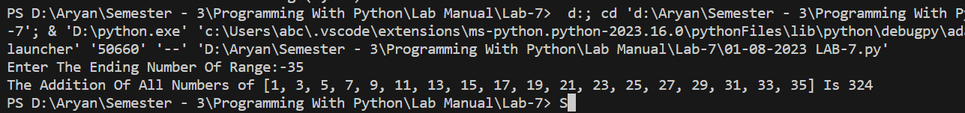

**Task 8:-** Python program to print a multiplication table of a given number

**Python Code:**

num = int(input("Enter A Number:-"))

ans = 1

for i in range(1,num + 1) :

ans = ans * i

print(f"The Factorial of {num} Is {ans}")

**Output:**

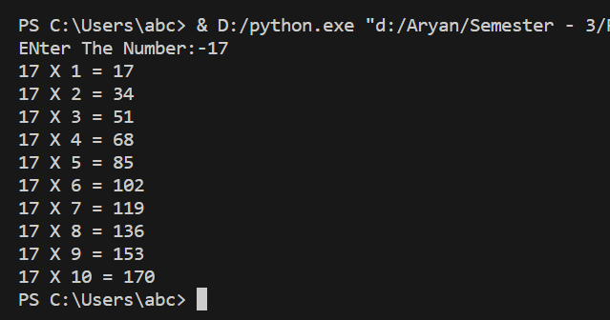

**Task 9:-** Python program to count the total number of digits in a number.

**Python Code:**

number = input("Enter A Number :- ")

print(f"There Are {len(number)} Digits In A {number}")

**Output:**

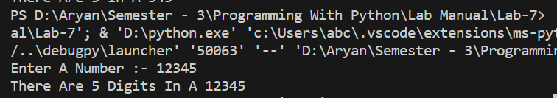

**Task 10 :-** Python program to check if the given string is a palindrome.

**Python Code:**

string = input("Enter A String:-")

revstring = string[::-1]

if(string == revstring) :

print(f"{string} Is Palindrome")

else :

print(f"{string} Is Not Palindrome")

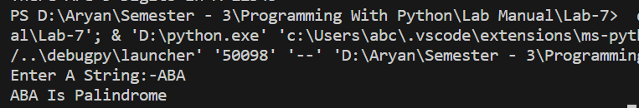**Output:**

**Task 11:-** Python program to find the factorial of a given number.

**Python Code:**

num = int(input("Enter A Number:-"))

ans = 1

for i in range(1,num + 1) :

ans = ans * i

print(f"The Factorial of {num} Is {ans}")

**Output:**

**Task 12 :-** Python program that accepts a string and calculates the number of digits and letters.

**Python Code:**

string = input("Enter A Number:-")

digit = char = 0

for i in string :

if i.isdigit() :

digit += 1

elif i.isalpha() :

char += 1

else :

continue

print(f"The Number Of Digits Is {digit} And Characters Is {char} In The String {string}")

**Output:**

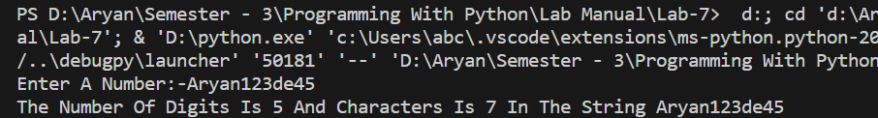

**Task 13:-** Print the following pattern

**Python Code:**

for i in range(0,5) :

for j in range(0,i+1) :

print("* ",end=" ")

for j in range(i,6) :

print(" ",end=" ")

print("\n")

for i in range(0,4) :

for j in range(0,4-i) :

print("* ",end=" ")

for j in range(0,i) :

print(" ",end=" ")

print("\n")

**Output:**

